Terraform Commands init  
  
terraform plan & apply  
  
Creating the resources

VPC

Subnet groups

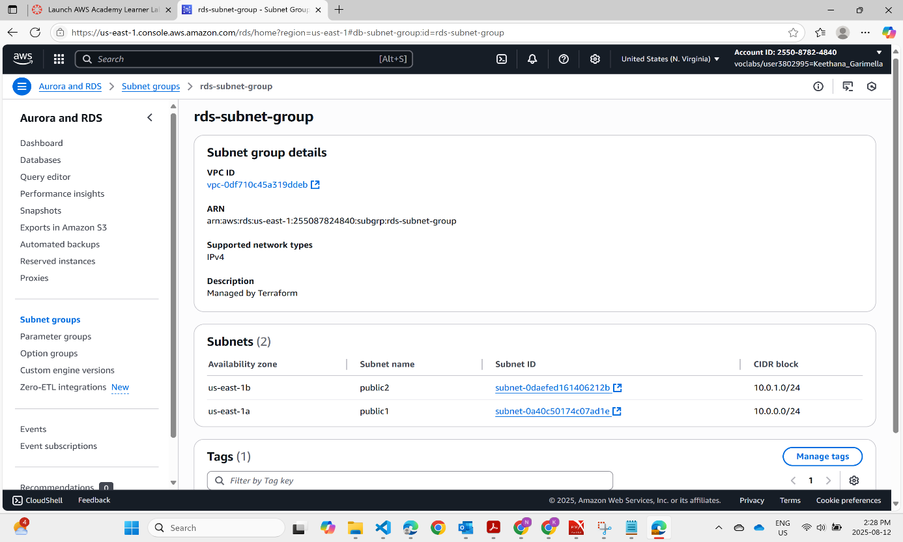

Public route table

Internet Gateway

s3 buckets

Cloudformation   
  
3 S3 buckets  
  
RDS creation

Deletion  
  
  
Destroyed

